1. Leap year

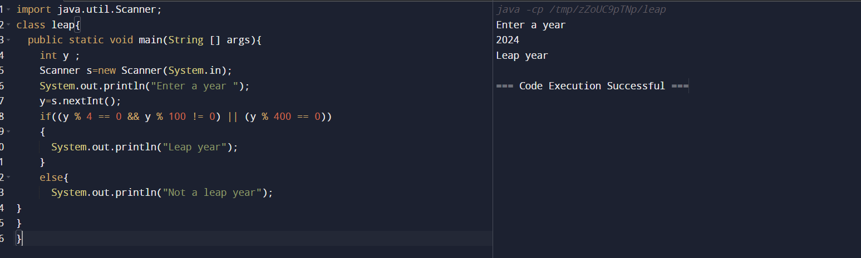

1. Two input one Output

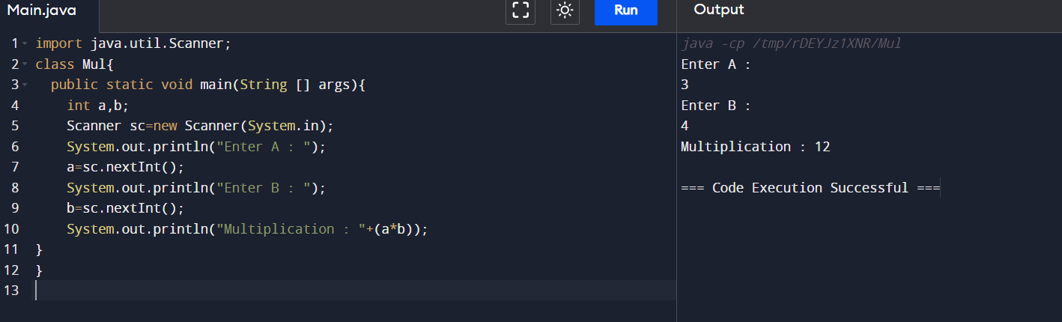

1. While loop (1 to 10)

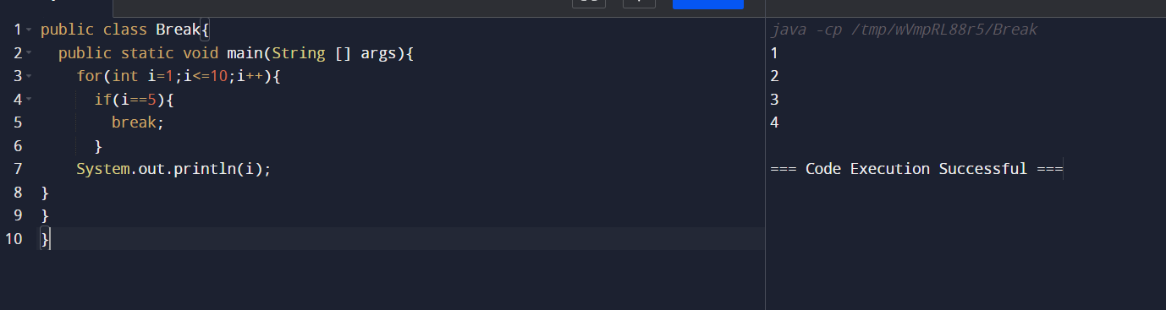

1. Nested If Else (Email pass Checker)

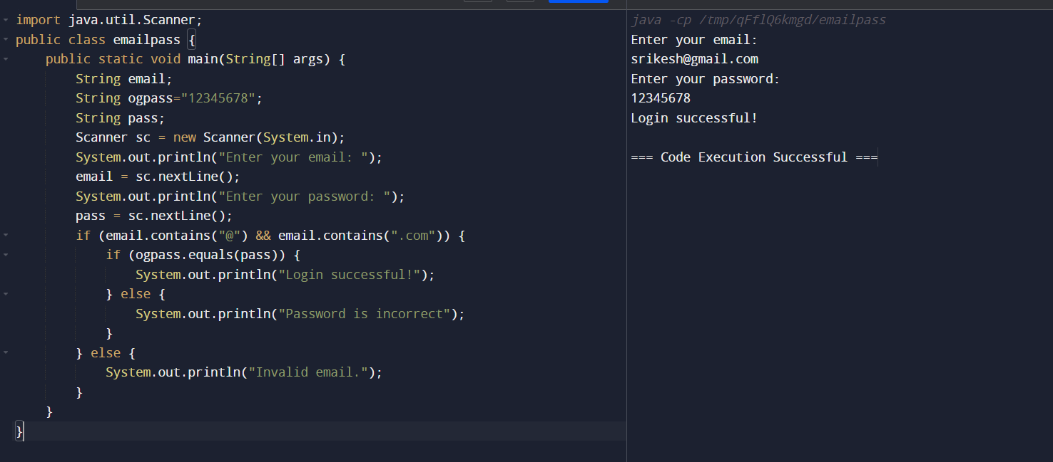

1. Getting string as input

